s./

Learning Report – Embedded C – Hardware + Programming + Testing

Course Code: <CODE>



|  |  |  |  |  |  |
| --- | --- | --- | --- | --- | --- |
| **Ver.Rel. No.** | **Release Date** | **Prepared. By** | **Reviewed By** | **Approved By** | **Remarks/Revision Details** |
| 1.0 | 02-12-2020 | Aruljothi C |  | Dr. Vivek K and Bhargav N |  |
|  |  |  |  |  |  |
|  |  |  |  |  |  |
|  |  |  |  |  |  |
|  |  |  |  |  |  |

**Document History**

Contents

1.0 Make Execution 4

**1.1 Files after execution of Make 5**

2.0 Mini project 6

1. SCREENSHOT OF THE PROJECT 6

2. Ouput of Project 6

# 1.0 Make Execution

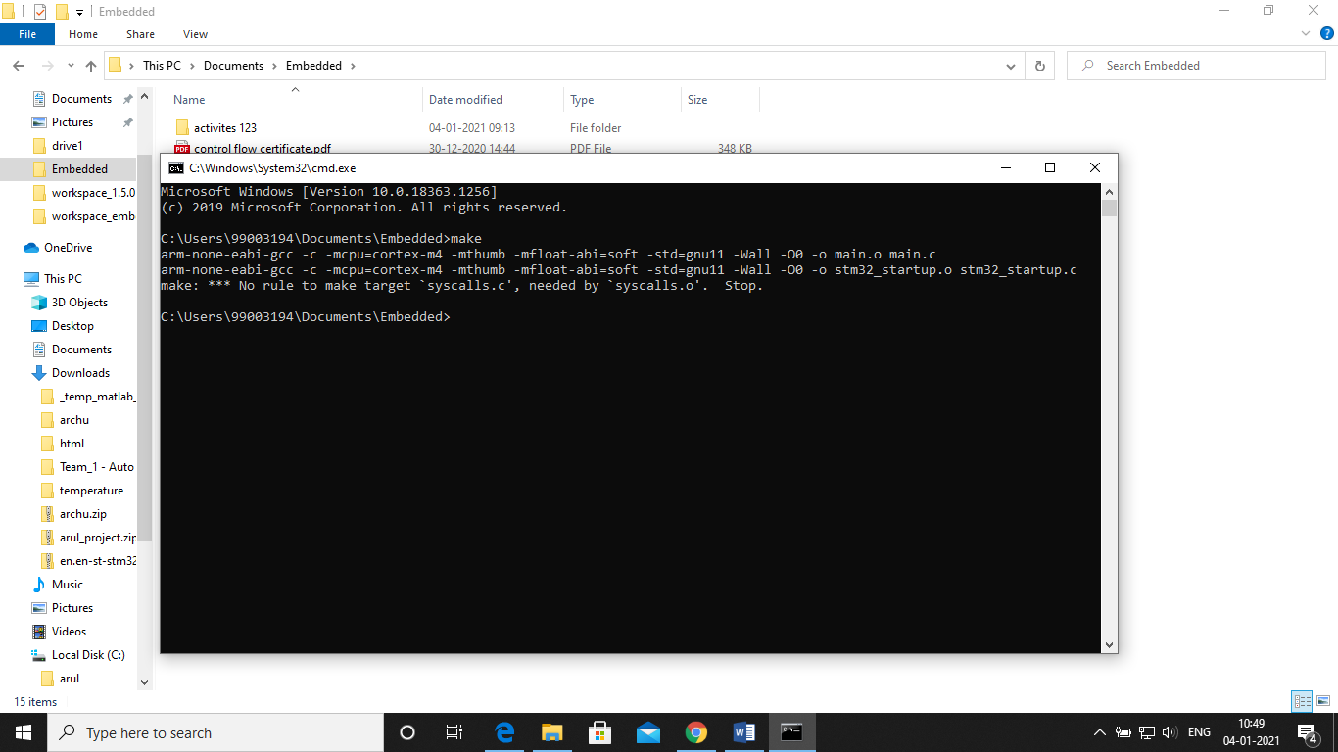

## **1.1 Files after execution of Make**

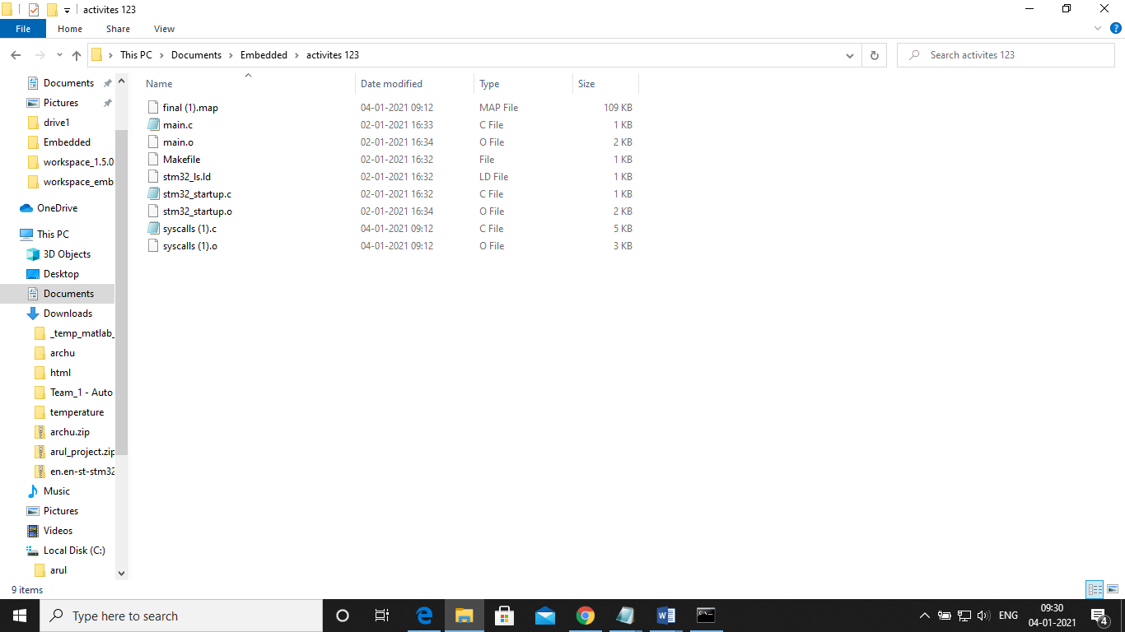

## **1.2 Project Files link**:

<https://lnttsgroup.sharepoint.com/:f:/r/sites/GEA/Global%20Engineering%20Academy/GENESIS%20%20Nov%202020%20Submission/Nov%202020%20Submission/Bangalore/2011BLRGT01/99003194/Embedded/Project?csf=1&web=1&e=NkbukH>

# Mini project

# Screenshot of the project

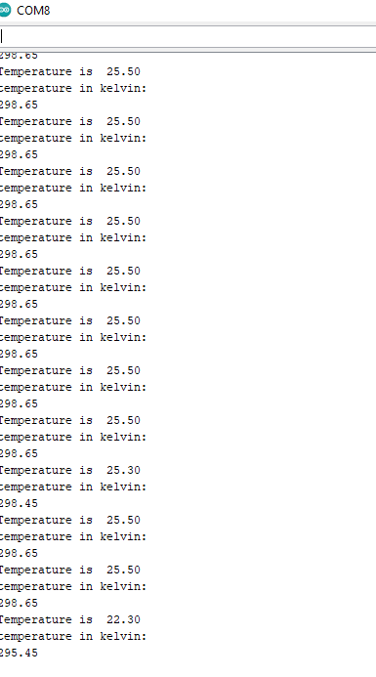

Fig.1. Screenshot of project output1

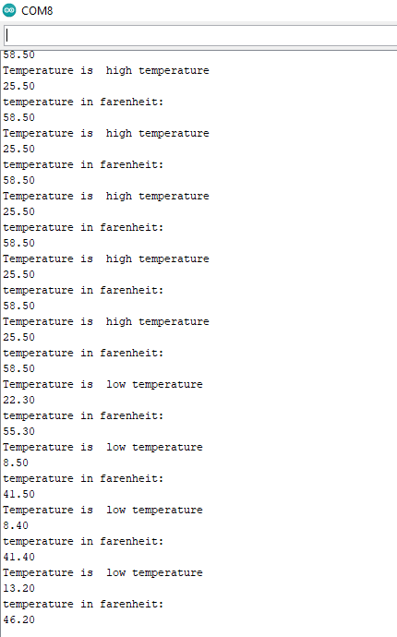

Fig.2. Screenshot of project output2